
The Night Before Return To Wonderland
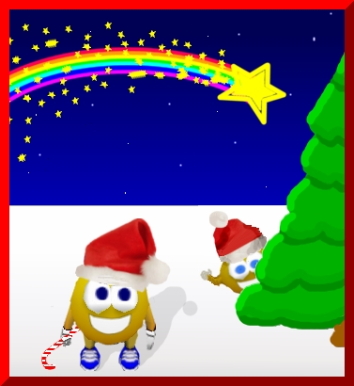

Twas the night before Wonderland, when all
Through the game not a person was stirring,
not even Sfseamen. The levels were played
as everyone would dare. In hopes that
Patrick would soon be there

The players were blowing up the kabooms all
through the night. While visions of coiley’s
danced within their sight. And Davimad in
her game and Ol'Gramma and her dogs quite bright Everyone just settled down for a tough fight.

When in the trees, Loof made such a clatter,
I sprang from the chair as if that would matter. Away in a hurry I flew like a flash
with Kabooms we did clash and then the Coily’s scattered.


The shining moon on Katja , the confining room
that lead to Sonja, she wished that the boulders would appear in hopes to destroy the objects near when what to my wondering should eyes appear, but Popo and her tiny reindeer.

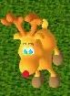
With a litte Majic, so lively and quick, I knew in a moment all must be rapid as Malcdelsol and his level they came, and he whistled, shouted and called them by name" Now, Kaboom! Now, Natascha! Now, Cat! Now,
and Davimad ! On, Janetgalle ! On, Loof !
On, Peegue ! and Stinky !

To the top of the trees! To the top of the
wall now run away, run away, run away all.
As Roger ran faster than the wind , he
meets up with a obstacle it is such a
sweet happiness to defend.


So behind the trees the boulder they roll,into the water to make a bridge to and throw for Old Pete and Robbie to cross with a great show. And then, in a second I heard in the trees Popo rustling about with her little reindeer for all to see.

With my mouse in my hand, and turning around behind me was Peegue ready to start defending Wonderland. Peegue all dressed in fur, from his head to his feet, in order to keep his clothes looking neat.

The land covered with snow as a bundle of
boulders begin to roll. And he looked with
surprise as he finished at last, now let's
go onto the next level really fast.

Loof's eyes how they twinkled, his dimples now glow! His cheeks were almost frozen, his nose was like a red cherry! His face glowed as he dreamed of seeing Majic again.

The expression on his face was as bright as the sun for he soon knew we all would be done! Stinky stumped through the kabooms in hopes to destroy them all, if not he would fail.

As the kabooms circled him,he started looking for away to escape.He knew his friends were close by and that they empowered to help. He was happy and pleased, and to see his friends, Loof laughed when he saw Stinky,in spite of himself I am glad I could help you, Old Friend!

A glow in his eyes and a twist of his head, soon gave us a smile that we had nothing
to fear; He spoke not a word, but headed
out of sight to a level, and he destroyed
all the z-bot 's with a cannon blast.

And rolling his boulder over the kabooms,
and giving a nod and a smile on his face.
He sprang to his car, to his team he gave a whistle, and away they all drove as fast as
a thistle.

But I heard him exclaim, when he drove out of sight,
“HAVE A MERRY CHRISTMAS AND A GOOD-NIGHT!”

